JSON REFINER ADVANCED EDITION
Project Report Submitted to Manonmaniam Sundaranar University in the Partial fulfilment of the Requirement for the Naan Mudhalvan Course (JSON REFINER ADVANCED EDITION).
Submitted By
Team ID: SWTID-2026-7750
Team Leader: VANAMURUGESHWARI.S- 23082241808412046
Team Member: MUTHULAKSHMI.P - 23082241808412030
Team Member: SNOWLEENA.S- 23082241808412043
Team Member: NILOOFAR NISHA.S- 23082241808412033
Team Member: KAVI VARSHINI.T- 23082241808412020


DEPARTMENT OF INFORMATION TECHNOLOGY
WAVOO WAJEEHA WOMEN’S COLLEGE OF ARTS & SCIENCE
KAYALPATNAM – 628 204
APRIL – 2026

CERTIFICATE

WAVOO WAJEEHA WOMEN’S COLLEGE OF ARTS AND SCIENCE
KAYALPATNAM – 628 204
CERTIFICATE
This is to certify that project entitled as
“JSON REFINER ADVANCED EDITION’’
Is a bonafide work done by
Team ID: SWTID-2026-7750
Team Leader: VANAMURUGESHWARI.S- 23082241808412046
Team Member: MUTHULAKSHMI.P - 23082241808412030
Team Member: SNOWLEENA.S- 23082241808412043
Team Member: NILOOFAR NISHA.S- 23082241808412033
Team Member: KAVI VARSHINI.T- 23082241808412020
In partial fulfillment of the requirement for B.Sc Degree Course in Information Technology (2025-2026) of the Manonmaniam Sundaranar University for Naan Mudhalvan Course (JSON REFINER ADVANCED EDITION) is done.

Signature of the Staff Incharge Signature of the H.O.D

EXTERNAL EXAMINERS:
1.
2.

DECLARATION

DECLARATION
This project is submitted for the Naan Mudhalvan Course Oracle App Development subject code ______________and the external examination is conducted on __________________.

Signature of the Candidates
1.VANAMURUGESHWARI.S

2. MUTHULAKSHMI.P

3.SNOWLEENA.S

4.NILOOFAR NISHA.S

5.KAVI VARSHINI.T

DATE:
PLACE: Kayalpatnam

CONTENT

TABLE OF CONTENT
S.NO | TABLE OF CONTENT | PAGE NO
1. | PROJECT DESCRIPTION | 1
2. | SCENARIOS | 3
3. | ARCHITECTURE OVERVIEW | 5
4. | PROJECT WORKFLOW | 8
5. | PROJECT STRUCTURE | 12
6. | IMPLEMENTATION PHASE | 15
7. | SCREENSHOTS | 30
8. | CONCLUSION | 34
9. | FUTURE ENHANCEMENT | 36

PROJECT DESCRIPTION

PROJECT DESCRIPTION
JSON Refiner Advanced Edition is an intelligent JSON processing platform designed to simplify the creation, transformation, validation, and refinement of JSON data. The system leverages Python’s powerful data processing capabilities along with an interactive web interface built using the Gradio framework to deliver a user-friendly and efficient solution for working with JSON data.
The primary objective of the system is to solve common challenges related to JSON data quality, format consistency, and validation. Many developers, analysts, and DevOps engineers frequently deal with unstructured or inconsistent data formats. JSON Refiner Advanced automates the process of converting raw key-value text into structured JSON while ensuring correct data types, proper formatting, and schema validation.
The platform includes advanced features such as automatic type inference, key normalization, multiple case style conversions (snake_case, camelCase, kebab-case, PascalCase), JSON flattening and unflattening, JSON merging, null value removal, and schema-based validation. The system also provides detailed statistics and error reporting to ensure data integrity.
The project is implemented using Python and integrates modern libraries such as JSONSchema for validation, JSON5 for flexible parsing, and Gradio for the graphical user interface. The tool is designed to be accessible through Google Colab or local environments, allowing users to process JSON data quickly and efficiently.
By combining intelligent data processing with an interactive user interface, JSON Refiner Advanced Edition transforms JSON manipulation into a fast, accurate, and user-friendly experience suitable for developers, analysts, and data engineers.

SCENARIOS

SCENARIOS
Scenario 1: Data Migration from CSV to JSON
A data analyst needs to convert flat CSV data into structured JSON format before uploading it into a database. The analyst enters key-value pairs extracted from the CSV file. The system automatically detects data types such as integers, floats, booleans, and strings. The tool then generates clean JSON output that can be directly used for database import or API integration.
Scenario 2: API Response Normalization
A backend developer receives API responses from multiple third-party services. Each API uses different naming conventions such as camelCase, snake_case, or PascalCase. The JSON Refiner tool converts all keys into a consistent naming format and removes unnecessary fields, making the data easier to integrate into applications.
Scenario 3: Configuration File Management
A DevOps engineer maintains configuration files written in simple text format. The tool converts configuration parameters into structured JSON format suitable for deployment systems. It also validates required fields and ensures that configuration data follows a predefined schema.
Scenario 4: Data Flattening for Analytics
An analytics team receives deeply nested JSON data from application logs. For easier analysis in tools such as Excel or CSV-based systems, the JSON Refiner can flatten nested objects into dot notation format. This makes the data easier to process and analyze.
Scenario 5: Schema-Based Data Validation
Quality assurance teams can use the tool to validate JSON data against predefined JSON schemas. This ensures that incoming data meets the required structure and prevents invalid data from entering production systems.

ARCHITECTURE OVERVIEW

ARCHITECTURE OVERVIEW
JSON Refiner Advanced is built as a modular platform combining a Python backend with advanced JSON processing algorithms for intelligent data transformation. The architecture focuses on maintaining data integrity, improving user experience, and ensuring production-ready output through Gradio's interactive interface and powerful validation mechanisms.
The system processes raw key-value inputs provided by the user and automatically converts them into structured JSON format. The backend engine performs various operations such as automatic type inference, key normalization, case style conversion, flattening and unflattening of JSON objects, and schema validation. These processing modules ensure that the generated JSON data is clean, standardized, and ready for use in applications, APIs, and data pipelines.
The user interface is built using the Gradio framework, which allows users to interact with the system through an intuitive web interface. Users can input data, choose transformation options, validate JSON structures, and instantly view the processed output. Error messages, statistics, and validation results are displayed to help users understand and correct data issues efficiently.
The modular design allows different components such as parsing, transformation, validation, and user interface to work independently. This makes the system scalable, maintainable, and easy to extend with additional features such as batch processing, API integration, or advanced data analytics in future versions.
Core Technologies
- Python 3.8+ – Main programming language for data processing and JSON transformation.
- Gradio 4.0+ – Creates an interactive web interface for users to run and view results.
- JSON5 – Allows flexible parsing of JSON input.
- JSONSchema – Validates JSON data against predefined schemas.
- Regular Expressions – Used for pattern matching and key normalization.
- Google Colab – Cloud environment to develop and run the project.
- HTML5/CSS3 – Used to design and display the user interface.

Pre-requisites
Software Requirements
- Python 3.8+
- Google Account (for Google Colab)
- pip (for installing libraries)
- Modern Web Browser (Chrome, Firefox, Edge, Safari)
- Internet Connection
Knowledge Requirements
- Basic Python programming
- Understanding of JSON structure
- Regular Expressions basics
- Gradio framework basics
- JSON Schema validation
- Basic use of Google Colab
Hardware Requirements
- Processor: Intel i3 or equivalent
- RAM: Minimum 2 GB
- Storage: 500 MB free space
- Display: 1024 × 768 resolution minimum.

PROJECT WORKFLOW

PROJECT WORKFLOW
Phase 1: Environment Setup & Core Architecture
Activity 1.1: Install Dependencies & Configure Environment
- Set up the Google Colab environment for development.
- Install required packages such as gradio, json5, jsonschema, python-dotenv, and pydantic.
- Create a requirements.txt file to manage dependencies.
- Verify that all libraries are installed and working properly.
Activity 1.2: Design Core Data Structures
- Define CaseStyle Enum to support different case formats (snake_case, camelCase, kebab-case, PascalCase).
- Develop the JSONRefinerCore class to handle all JSON processing tasks.
- Design a type inference system for automatic data type detection.
- Implement error tracking mechanisms to report parsing issues.
Phase 2: Core JSON Processing Engine
Activity 2.1: Implement Type Inference System
- Create the infer_type() method to detect data types automatically.
- Handle boolean values such as true/false, yes/no, on/off.
- Support null values like null, none, and nil.
- Parse numbers, arrays, and JSON objects from input strings.
- Default to string type when values cannot be identified.
Activity 2.2: Build Key Normalization & Case Conversion
- Implement case conversion functions:
  - to_snake_case()
  - to_camelCase()
  - to_kebab_case()
  - to_pascal_case()
- Create a normalize_key() method to apply the selected case style automatically.
- Test all case conversion combinations.
Phase 3: Validation & Transformation Features
Activity 3.1: JSON Schema Validation
- Implement validate_json_schema() method using the jsonschema library.
- Perform Draft7 schema validation.
- Format and display validation error messages.
Activity 3.2: Required Fields Checking
- Create check_required_fields() method to verify mandatory fields.
- Detect and report missing fields.
- Combine results with schema validation.
Activity 3.3: JSON Transformation Methods
- Implement flatten_json() for converting nested JSON into flat format.
- Implement unflatten_json() to rebuild nested structures.
- Create merge_json_objects() for deep merging of JSON data.
- Implement remove_null_values() for data cleaning.
- Test transformations with complex JSON structures.
Phase 4: Gradio Interface Development
Activity 4.1: Design Core Refining Tab
- Create input fields for key-value text.
- Add case style selection using radio buttons.
- Include options for removing null values and flattening JSON.
- Display processed data in a JSON output panel.
- Provide status messages and statistics for user feedback.
Phase 5: Integration, Testing & Deployment
Activity 5.1: Google Colab Deployment
- Integrate backend functions with the Gradio interface.
- Connect all interface tabs.
- Test the complete JSON processing pipeline.
- Verify proper error handling.
Activity 5.2: Comprehensive Testing
- Test all case conversion styles.
- Verify type inference accuracy.
- Validate JSON using different schema definitions.
- Test JSON merging and flattening with complex data.
TECHNICAL ARCHITECTURE
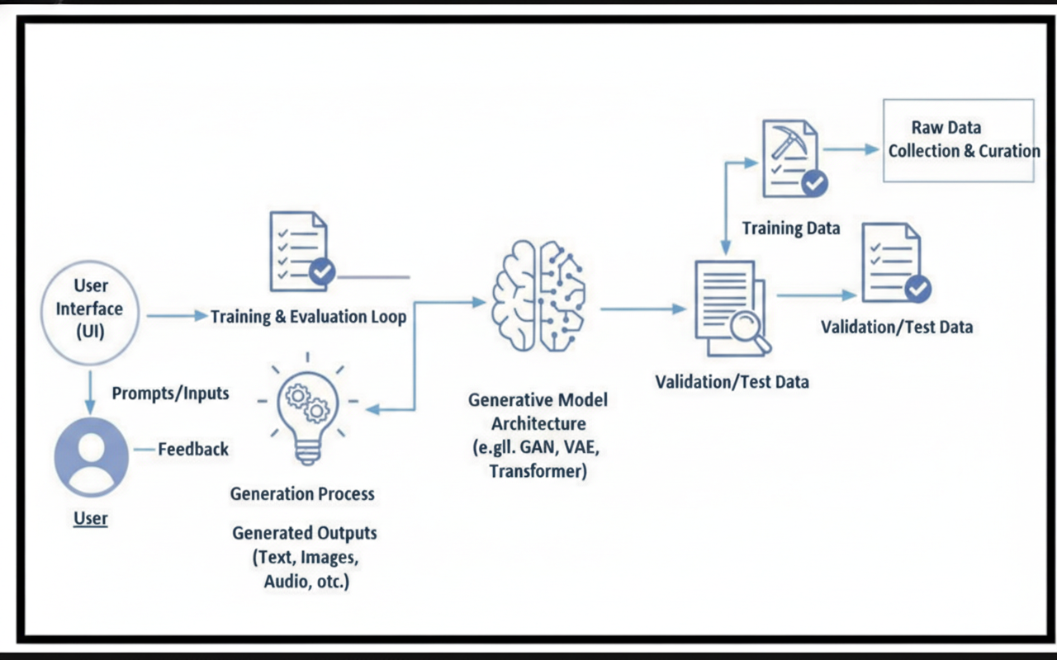

PROJECT STRUCTURE

PROJECT STRUCTURE
The JSON Refiner Advanced Edition Architecture illustrates how different components of the system interact to process, validate, and transform JSON data efficiently.
1. Frontend Interface
The system provides a Gradio-based user interface that allows users to interact with the application. Through this interface, users can:
- Input key-value data
- Perform JSON refining operations
- Validate JSON data
- Convert key case formats
- Merge and flatten JSON structures
- View processing history and guides
The user input is sent to the core processing engine for further processing.
2. Core Processing Engine
The Core Processing Engine is the central component responsible for handling JSON operations. It includes several modules:
- Type Inference System – Automatically detects data types such as strings, numbers, booleans, and null values.
- Case Conversion Module – Converts JSON keys into formats like snake_case, camelCase, kebab-case, and PascalCase.
- Schema Validation – Ensures that JSON data follows defined JSON schema rules.
- Transformation Suite – Performs operations like flattening, unflattening, merging JSON objects, and removing null values.
- History & Error Logging – Tracks user actions and logs errors for debugging and reporting.

3. Backend & Deployment
The backend system is implemented using Python 3.8+ and integrates several libraries for data processing:
- JSON5 Parsing for flexible JSON handling
- Regular Expressions for key normalization
- Pydantic Validation for structured data validation
The application is deployed on Google Colab, which provides a cloud-based environment for running the Gradio interface and executing JSON processing tasks.
4. Data Validation & Output
After processing, the system generates validated JSON outputs, which can be used for:
- JSON Schema validation
- API integration
- Database storage
- Data transformation workflows
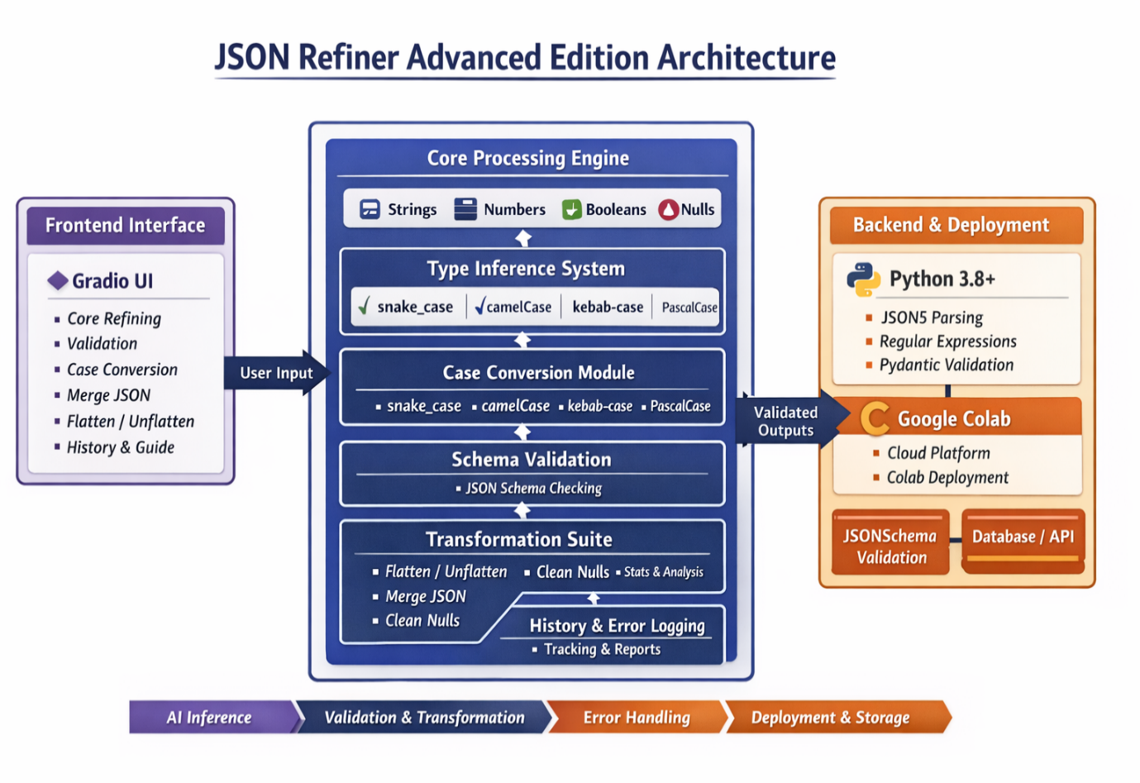

IMPLEMENTATION PHASE

IMPLEMENTATION PHASE
MILESTONE 1: Environment Setup & Core Architecture
Activity 1.1: Install Dependencies
Load the model :
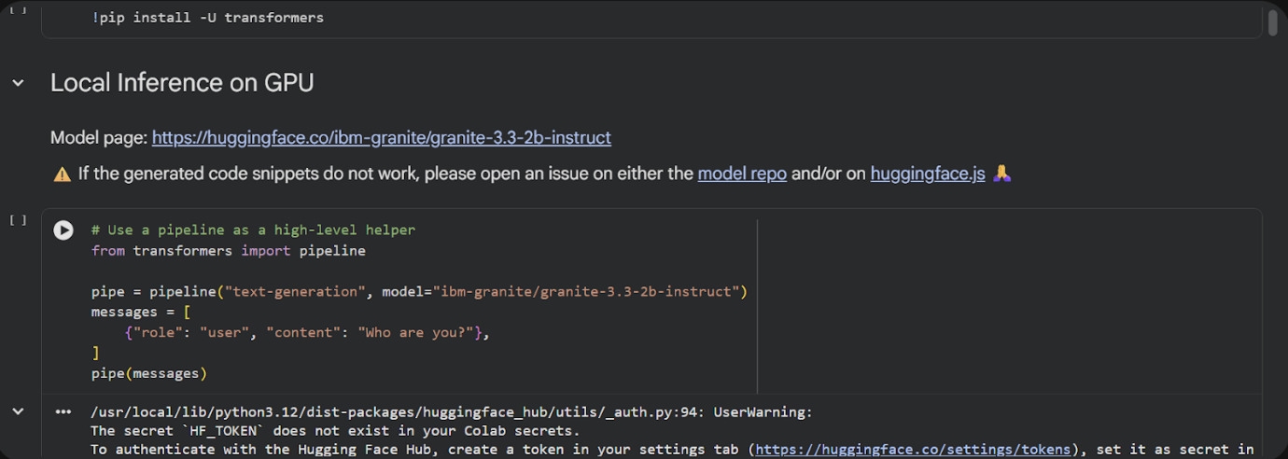
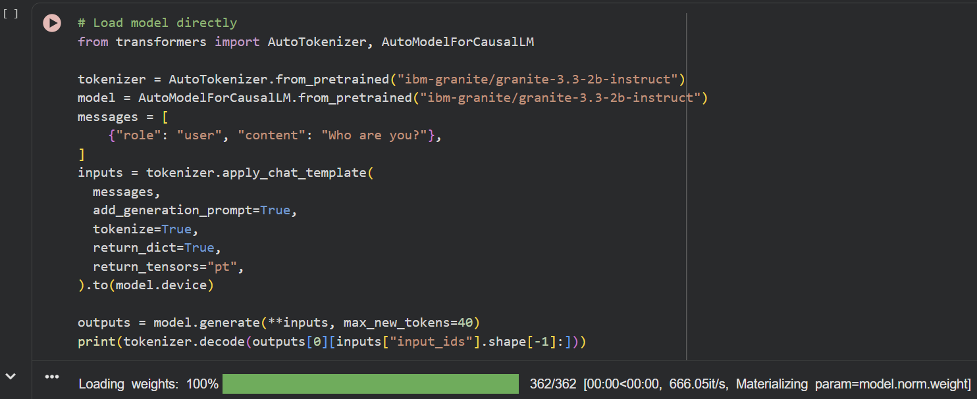
Create requirements.txt with the following dependencies:
• gradio==4.0+
• json5==0.9.6+
• jsonschema==4.17.0+
• python-dotenv==0.19.0+
• pydantic==1.9.0+
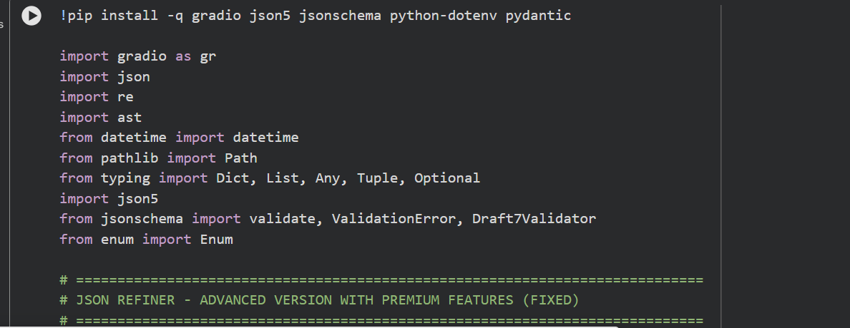
Activity 1.2: Initialize Enum and Core Class
import gradio as gr
import json
import re
from datetime import datetime
from enum import Enum
from typing import Dict, List, Any, Tuple
from collections import deque
from jsonschema import validate, ValidationError
class CaseStyle(Enum):
SNAKE_CASE = "snake_case"
CAMEL_CASE = "camelCase"
KEBAB_CASE = "kebab-case"
PASCAL_CASE = "PascalCase"
class JSONRefinerCore:
@staticmethod
def to_snake_case(text: str) -> str:
text = re.sub(r'[\s\-]+', '_', text)
text = re.sub(r'([a-z])([A-Z])', r'\1_\2', text)
text = re.sub(r'[^a-zA-Z0-9_]', '', text)
return text.lower()
@staticmethod
def to_camel_case(text: str) -> str:
snake = JSONRefinerCore.to_snake_case(text)
parts = snake.split('_')
return parts[0] + ''.join(word.capitalize() for word in parts[1:])
@staticmethod
def to_kebab_case(text: str) -> str:
snake = JSONRefinerCore.to_snake_case(text)
return snake.replace("_", "-")
@staticmethod
def to_pascal_case(text: str) -> str:
camel = JSONRefinerCore.to_camel_case(text)
return camel[0].upper() + camel[1:] if camel else ""
@staticmethod
def normalize_key(key: str, case_style: CaseStyle):
key = key.strip()
if case_style == CaseStyle.SNAKE_CASE:
return JSONRefinerCore.to_snake_case(key)
if case_style == CaseStyle.CAMEL_CASE:
return JSONRefinerCore.to_camel_case(key)
if case_style == CaseStyle.KEBAB_CASE:
return JSONRefinerCore.to_kebab_case(key)
if case_style == CaseStyle.PASCAL_CASE:
return JSONRefinerCore.to_pascal_case(key)
return key
@staticmethod
def infer_type(value: str):
value = value.strip()
if value.lower() in ["null", "none", "nil", "undefined"]:
return None
if value.lower() in ["true", "yes", "on"]:
return True
if value.lower() in ["false", "no", "off"]:
return False
try:
if "." not in value:
return int(value)
except:
pass
try:
return float(value)
except:
pass
if value.startswith("[") and value.endswith("]"):
try:
return json.loads(value)
except:
pass
if value.startswith("{") and value.endswith("}"):
try:
return json.loads(value)
except:
pass
return value
@staticmethod
def parse_key_value_text(text: str, case_style: CaseStyle):
result = {}
errors = []
lines = text.split("\n")
for i, line in enumerate(lines, 1):
line = line.strip()
if not line or line.startswith("#"):
continue
if ":" not in line:
errors.append(f"Line {i}: Missing ':' separator")
continue
key, value = line.split(":", 1)
key = key.strip()
value = value.strip()
if not key:
errors.append(f"Line {i}: Empty key")
continue
normalized = JSONRefinerCore.normalize_key(key, case_style)
converted_value = JSONRefinerCore.infer_type(value)
if normalized in result:
errors.append(f"Duplicate key '{normalized}' overwritten")
result[normalized] = converted_value
return result, errors
@staticmethod
def flatten_json(data: Dict, parent_key="", sep="."):
items = []
for k, v in data.items():
new_key = f"{parent_key}{sep}{k}" if parent_key else k
if isinstance(v, dict):
items.extend(
JSONRefinerCore.flatten_json(v, new_key, sep).items())
elif isinstance(v, list):
for i, item in enumerate(v):
if isinstance(item, dict):
items.extend(
JSONRefinerCore.flatten_json(
item, f"{new_key}.{i}", sep).items())
else:
items.append((f"{new_key}.{i}", item))
else:
items.append((new_key, v))
return dict(items)
@staticmethod
def unflatten_json(data: Dict, sep="."):
result = {}
for key, value in data.items():
parts = key.split(sep)
current = result
for part in parts[:-1]:
if part not in current:
current[part] = {}
current = current[part]
current[parts[-1]] = value
return result
@staticmethod
def merge_json_objects(*objects):
result = {}
for obj in objects:
for k, v in obj.items():
if (
k in result
and isinstance(result[k], dict)
and isinstance(v, dict) ):
result[k] = JSONRefinerCore.merge_json_objects(result[k], v)
else:
result[k] = v
return result
@staticmethod
def remove_null_values(data: Dict):
result = {}
for k, v in data.items():
if v is None:
continue
if isinstance(v, dict):
result[k] = JSONRefinerCore.remove_null_values(v)
else:
result[k] = v
return result
@staticmethod
def get_json_stats(data: Dict):
def count(obj):
if isinstance(obj, dict):
total = len(obj)
nested = 0
for v in obj.values():
c, n = count(v)
nested += c + n
return total, nested
if isinstance(obj, list):
total = len(obj)
nested = 0
for item in obj:
c, n = count(item)
nested += c + n
return total, nested
return 0, 0
top, nested = count(data)
return {
"top_level_keys": top,
"total_keys": top + nested,
"has_nested": any(isinstance(v, dict) for v in data.values()),
"has_arrays": any(isinstance(v, list) for v in data.values()),
"value_types": list(set(type(v).__name__ for v in data.values())), }
refiner = JSONRefinerCore()
history = deque(maxlen=100)
def refine_json(text, case_style, remove_nulls, flatten, pretty):
if not text.strip():
return "", "❌ Empty input", ""
case_enum = CaseStyle(case_style)
data, errors = refiner.parse_key_value_text(text, case_enum)
if remove_nulls:
data = refiner.remove_null_values(data)
if flatten:
data = refiner.flatten_json(data)
if pretty:
output = json.dumps(data, indent=2)
else:
output = json.dumps(data)
stats = refiner.get_json_stats(data)
stats_text = f"""
Top Level Keys: {stats['top_level_keys']}
Total Keys: {stats['total_keys']}
Has Nested: {stats['has_nested']}
Has Arrays: {stats['has_arrays']}
Types: {', '.join(stats['value_types'])}"""
history.append( {
"time": datetime.now().isoformat(),
"input": text,
"output": output, } )
status = "✅ JSON generated"
if errors:
status += "\nWarnings:\n" + "\n".join(errors)
return output, status, stats_text
def validate_json(json_text, schema_text, required):
try:
data = json.loads(json_text)
messages = []
if required.strip():
fields = [f.strip() for f in required.split(",")]
missing = [f for f in fields if f not in data]
if missing:
messages.append("Missing: " + ", ".join(missing))
else:
messages.append("Required fields OK")
if schema_text.strip():
schema = json.loads(schema_text)
try:
validate(data, schema)
messages.append("Schema valid")
except ValidationError as e:
messages.append(str(e))
if not messages:
messages.append("Valid JSON")
return "\n".join(messages), "Validation done"
except Exception as e:
return str(e), "Validation error"
def convert_case(json_text, target):
try:
data = json.loads(json_text)
case_enum = CaseStyle(target)
def convert(obj):
if isinstance(obj, dict):
return {
refiner.normalize_key(k, case_enum): convert(v)
for k, v in obj.items() }
if isinstance(obj, list):
return [convert(i) for i in obj]
return obj
result = convert(data)
return json.dumps(result, indent=2), "Converted"
except Exception as e:
return "", str(e)
with gr.Blocks(title="JSON Refiner Advanced") as demo:
gr.Markdown("# 🚀 JSON Refiner Advanced")
with gr.Tab("Refine"):
text_input = gr.Textbox(
label="Key Value Input",
lines=10,
value="name: John\nage: 30\nactive: true", )
case_style = gr.Radio(
["snake_case", "camelCase", "kebab-case", "PascalCase"],
value="snake_case", )
remove_nulls = gr.Checkbox(label="Remove Nulls")
flatten = gr.Checkbox(label="Flatten")
pretty = gr.Checkbox(label="Pretty Print", value=True)
btn = gr.Button("Refine JSON")
output = gr.Code(language="json")
status = gr.Markdown()
stats = gr.Markdown()
btn.click(
refine_json,
[text_input, case_style, remove_nulls, flatten, pretty],
[output, status, stats],)
with gr.Tab("Validate"):
json_input = gr.Code(language="json")
schema = gr.Code(language="json")
required = gr.Textbox(label="Required fields")
btn2 = gr.Button("Validate")
result = gr.Markdown()
status2 = gr.Markdown()
btn2.click(
validate_json,
[json_input, schema, required],
[result, status2], )
with gr.Tab("Case Conversion"):
json_case = gr.Code(language="json")
target_case = gr.Radio(
["snake_case", "camelCase", "kebab-case", "PascalCase"] )
btn3 = gr.Button("Convert")
case_output = gr.Code(language="json")
case_status = gr.Markdown()
btn3.click(
convert_case,
[json_case, target_case],
[case_output, case_status], )
demo.launch()

SCREENSHOTS

SCREENSHOTS
Google Colab Deployment
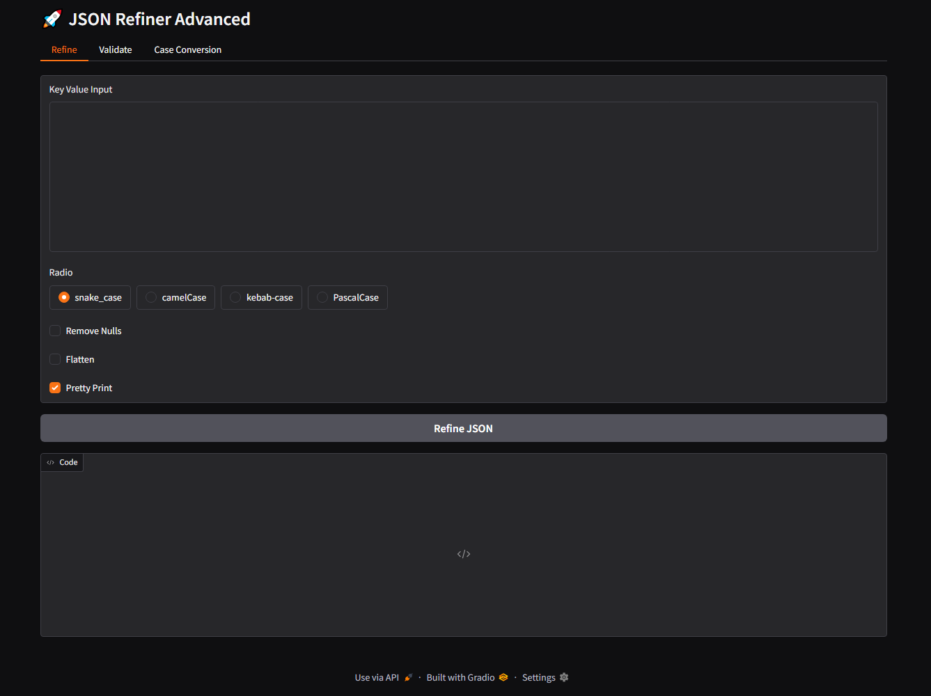
Functional Testing
Input:
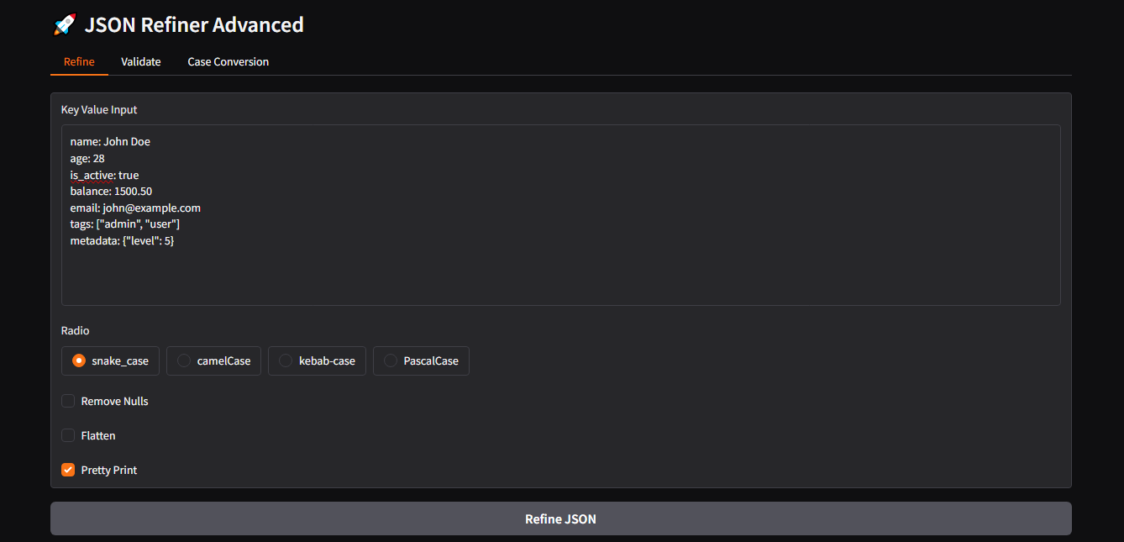
Output :
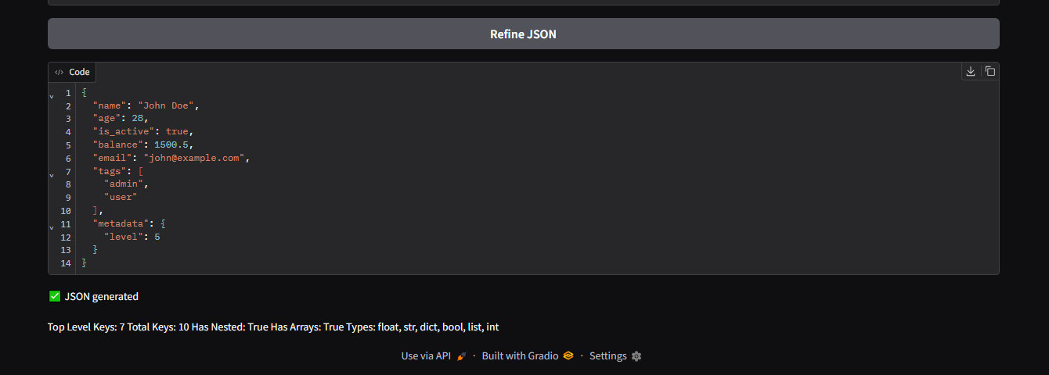

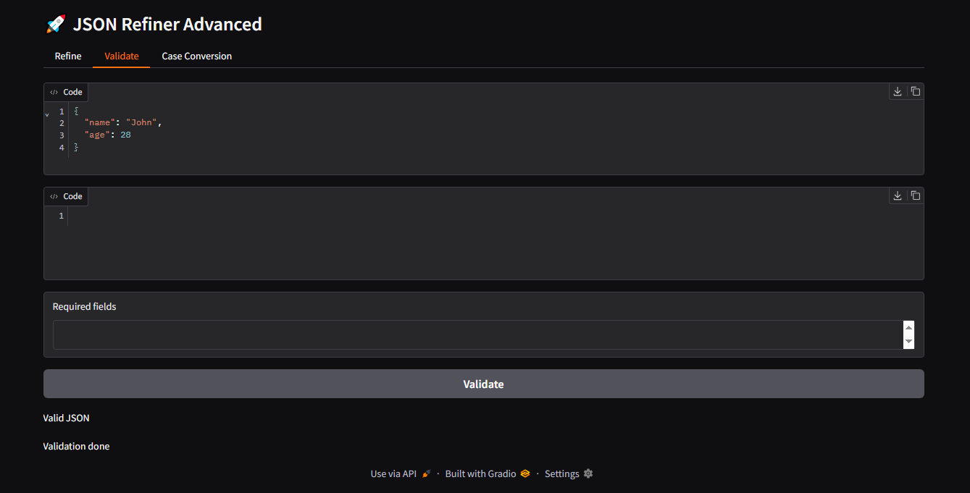

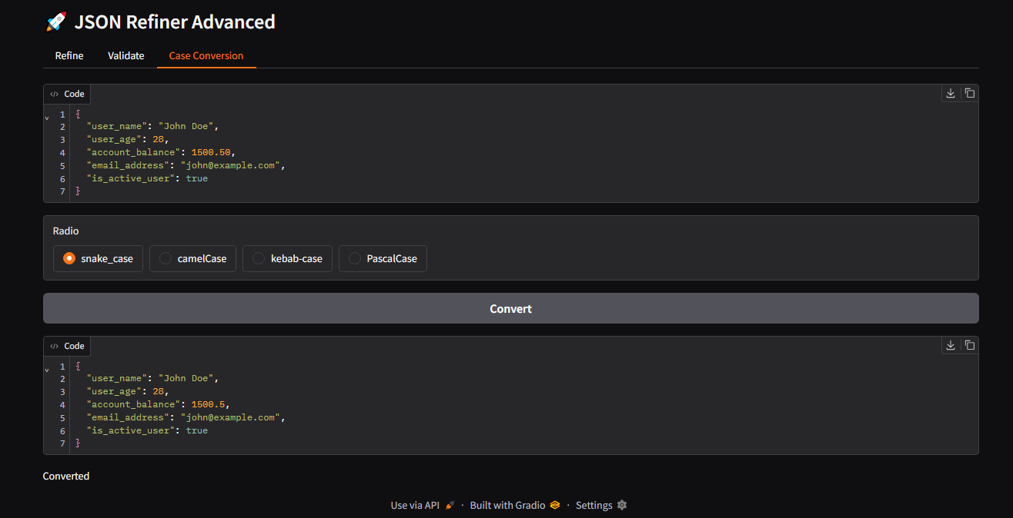

CONCLUSION

CONCLUSION
The developed system demonstrates an efficient approach for refining and managing JSON data using Python-based processing techniques and an interactive user interface. The application integrates the IBM Granite 3.3-2B language model, JSON processing utilities, and a Gradio-based web interface to provide a flexible platform for transforming key-value text into structured JSON.
The system supports multiple functionalities such as key normalization with different case styles (snake_case, camelCase, kebab-case, and PascalCase), automatic data type inference, JSON flattening and unflattening, removal of null values, JSON merging, validation against schemas, and statistical analysis of JSON structures. These features improve data consistency, readability, and usability for developers and data engineers.
Additionally, the integration of an intuitive graphical interface allows users to interact with the system easily without requiring deep programming knowledge. Overall, the project successfully demonstrates how modern NLP models and data processing techniques can be combined to create an intelligent JSON refinement tool.

FUTURE ENHANCEMENT

FUTURE ENHANCEMENT
Although the current system provides several useful functionalities, there are opportunities for further improvements and expansion:
- Support for File Uploads
Allow users to upload JSON, CSV, or TXT files directly instead of manually entering key-value text.
- Real-Time AI Suggestions
Use the Granite model to automatically suggest better JSON structures, key names, and schema corrections.
- Advanced Schema Generation
Implement automatic JSON schema generation based on input data patterns.
- Database Integration
Connect the system with databases such as MongoDB or PostgreSQL to store and retrieve refined JSON data.
- API Integration
Develop REST APIs so that external applications can use the JSON refiner service programmatically.
- Performance Optimization
Improve processing speed and scalability for handling large JSON datasets.
- User Authentication System
Add login and role-based access control for secure usage in enterprise environments.
- Visualization Dashboard
Provide graphical visualizations of JSON structures and statistics for better data analysis.
WEBSITE:
https://github.com/vanamurugeshwari-21/JSON_REFINER.git

